

# 

### Semester Two Examination, 2016

### Question/Answer Booklet

# MATHEMATICS

**SOLUTIONS**

**APPLICATIONS**

**UNITS 3 AND 4**

## Section One:

## Calculator-free

|  |  |  |  |  |  |  |  |  |
| --- | --- | --- | --- | --- | --- | --- | --- | --- |
| Student Number: In figures |  |  |  |  |  |  |  |  |

In words

Your name

## Time allowed for this section

Reading time before commencing work: five minutes

Working time for section: fifty minutes

## Materials required/recommended for this section

***To be provided by the supervisor***

This Question/Answer Booklet

Formula Sheet

***To be provided by the candidate***

Standard items: pens (blue/black preferred), pencils (including coloured), sharpener, correction fluid/tape, eraser, ruler, highlighters

Special items: nil

## Important note to candidates

No other items may be taken into the examination room. It is **your** responsibility to ensure that you do not have any unauthorised notes or other items of a non-personal nature in the examination room. If you have any unauthorised material with you, hand it to the supervisor **before** reading any further.

## Structure of this paper

|  |  |  |  |  |  |
| --- | --- | --- | --- | --- | --- |
| Section | Number of questions available | Number of questions to be answered | Working  time (minutes) | Marks available | Percentage of exam |
| Section One:  Calculator-free | 8 | 8 | 50 | 52 | 35 |
| Section Two:  Calculator-assumed | 13 | 13 | 100 | 97 | 65 |
|  | | | **Total** | 149 | 100 |

## Instructions to candidates

1. The rules for the conduct of examinations are detailed in the school handbook. Sitting this examination implies that you agree to abide by these rules.

2. Write your answers in this Question/Answer Booklet.

3. You must be careful to confine your response to the specific question asked and to follow any instructions that are specified to a particular question.

4. Spare pages are included at the end of this booklet. They can be used for planning your responses and/or as additional space if required to continue an answer.

* Planning: If you use the spare pages for planning, indicate this clearly at the top of the page.
* Continuing an answer: If you need to use the space to continue an answer, indicate in the original answer space where the answer is continued, i.e. give the page number. Fill in the number of the question that you are continuing to answer at the top of the page.

5. **Show** **all your working clearly**. Your working should be in sufficient detail to allow your answers to be checked readily and for marks to be awarded for reasoning. Incorrect answers given without supporting reasoning cannot be allocated any marks. For any question or part question worth more than two marks, valid working or justification is required to receive full marks. If you repeat any question, ensure that you cancel the answer you do not wish to have marked.

6. It is recommended that you **do not use pencil**, except in diagrams.

7. The Formula Sheet is **not** to be handed in with your Question/Booklet.

Section One: Calculator-free 35% (52 Marks)

This section has**eight (****8)** questions. Answer **all** questions. Write your answers in the spaces provided.

Working time for this section is 50 minutes.

Question 1 (5 marks)

(a) Re-draw the following graph to clearly illustrate that it is planar. (2 marks)

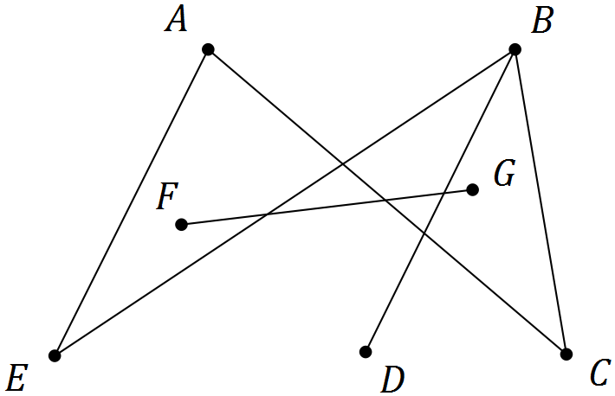

|  |
| --- |
| **Solution** |
|  |
| **Specific behaviours** |
| ✓ graph has no edges that cross  ✓ correct, disconnected version of graph |

(b) A digraph is shown below.

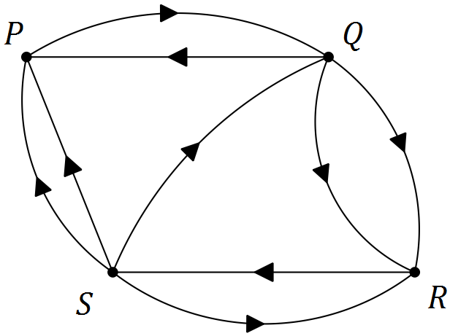

(i) Construct an adjacency matrix $M$ from the digraph. (2 marks)

|  |
| --- |
| **Solution** |
| $$\begin{matrix} & & \text{To} \\ & & \begin{matrix}P & Q & R & S\end{matrix} \\ \text{From} & \begin{matrix}P \\ Q \\ R \\ S\end{matrix} & \left[\begin{matrix}0 & 1 & 0 & 0 \\ 1 & 0 & 2 & 0 \\ 0 & 0 & 0 & 1 \\ 2 & 1 & 1 & 0\end{matrix}\right]\end{matrix}$$ |
| **Specific behaviours** |
| ✓ at least 14 elements correct using from/to convention unless labelled otherwise  ✓ all 16 elements correct |

(ii) Explain what information the matrix $M^{2}$ would show. (1 mark)

|  |
| --- |
| **Solution** |
| The number of two stage pathways between vertices in the graph |
| **Specific behaviours** |
| ✓ explanation |

Question 2 (7 marks)

The number of laptop computers, $T_{n}$, that were brought to a school IT department for recharging during week $n$ of the school year can be described recursively by the rule

$$T_{n+1}=T_{n}+3, T_{4}=16$$

(a) Use the rule to complete the table below. (2 marks)

|  |  |  |  |  |  |  |  |
| --- | --- | --- | --- | --- | --- | --- | --- |
| $$n$$ | 1 | 2 | 3 | 4 | 5 | 6 | 7 |
| $$T_{n}$$ | 7 | 10 | 13 | 16 | 19 | 22 | 25 |

|  |
| --- |
| **Solution** |
| See table |
| **Specific behaviours** |
| ✓ writes terms for  ✓ writes terms for $n=1,2,3$ |

(b) Display the terms of the sequence from the table on the graph below. (2 marks)

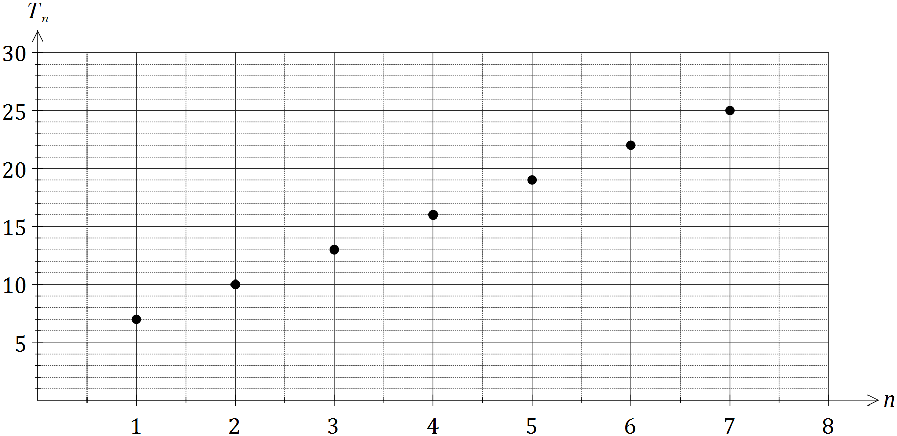

|  |
| --- |
| **Solution** |
| See graph |
| **Specific behaviours** |
| ✓ plots at least five points accurately  ✓ plots seven points accurately, no attempt to join them |

(c) A rule to determine the number of laptops brought for recharging during week $n$ can also be written in the form $T_{n}=an+b$. Determine the values of $a$ and $b$. (2 marks)

|  |
| --- |
| **Solution** |
| $T_{n}=7+\left(n-1\right)\left(3\right)=3n+4$ $a=3, b=4$ |
| **Specific behaviours** |
| ✓ determines value of  ✓ determines value of $b$ |

(d) If the pattern continued, determine the number of the week during which the number of laptops brought in for recharging first exceeds 50. (1 mark)

|  |
| --- |
| **Solution** |
| $3n+4=50, n=15\frac{1}{3}.$ During week 16. |
| **Specific behaviours** |
| ✓ states correct week |

Question 3 (6 marks)

The network below shows the distances, in kilometres, between nine towns, P, Q, R, ..., X.

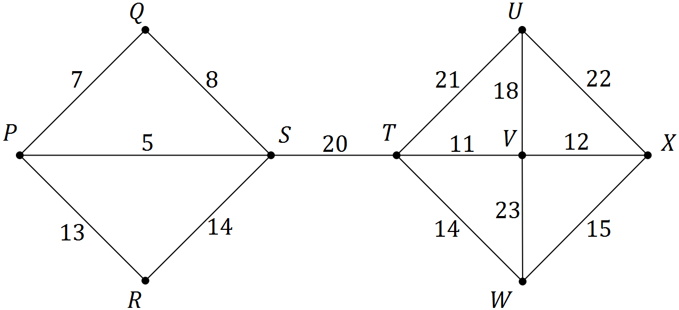

(a) Use Prim's algorithm, starting from P, to determine a minimum spanning tree for the network and draw the minimum spanning tree below. (3 marks)

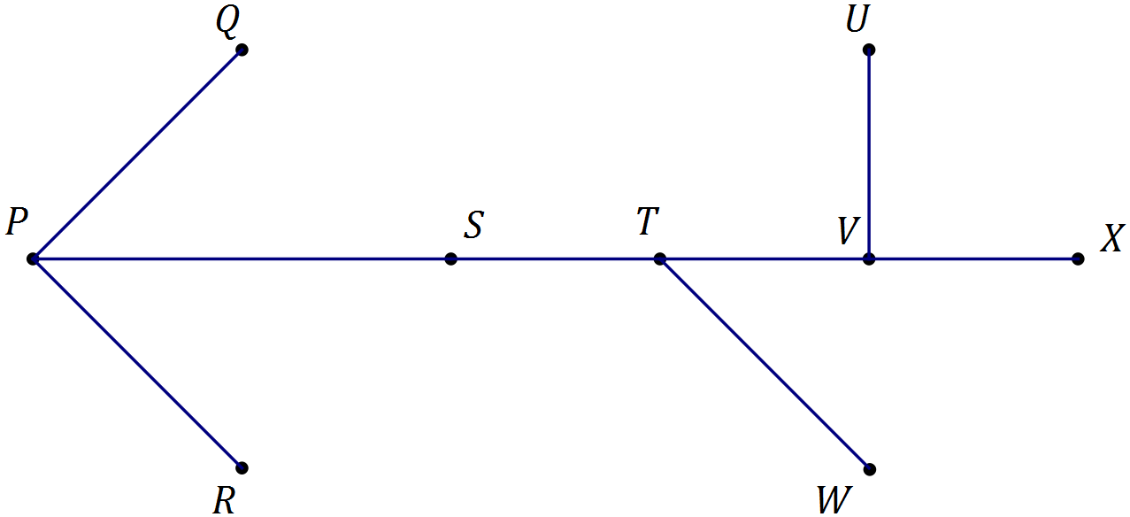

|  |
| --- |
| **Solution** |
| Highlights given network, draws tree |
| **Specific behaviours** |
| ✓ shows at least 7 correct edges  ✓ shows all required edges  ✓ draws tree, no cycles |

Working space for table – not needed

(b) State the length of the minimum spanning tree. (1 mark)

|  |
| --- |
| **Solution** |
| $5+7+13+20+11+12+14+18=100$ km |
| **Specific behaviours** |
| ✓ states length |

Question 4 (7 marks)

The table below shows the number of members, $N$, of a swimming club who turned up for training over the first three weeks of winter. The club trained on Monday, Tuesday, Wednesday and Thursday each week.

|  |  |  |  |  |  |  |  |  |  |  |  |  |
| --- | --- | --- | --- | --- | --- | --- | --- | --- | --- | --- | --- | --- |
|  | Week 1 | | | | Week 2 | | | | Week 3 | | | |
| Day | M | T | W | T | M | T | W | T | M | T | W | T |
| Time, $t$ | 1 | 2 | 3 | 4 | 5 | 6 | 7 | 8 | 9 | 10 | 11 | 12 |
| Number, $N$ | 35 | 33 | 19 | 21 | 32 | 29 | 4 | 21 | 30 | 25 | 19 | 20 |

(a) Construct a time series plot of this data on the axes below. (2 marks)

|  |
| --- |
| **Solution** |
| See graph |
| **Specific behaviours** |
| ✓ plots at least six points correctly  ✓ plots all points correctly  *(no requirement to connect points)* |

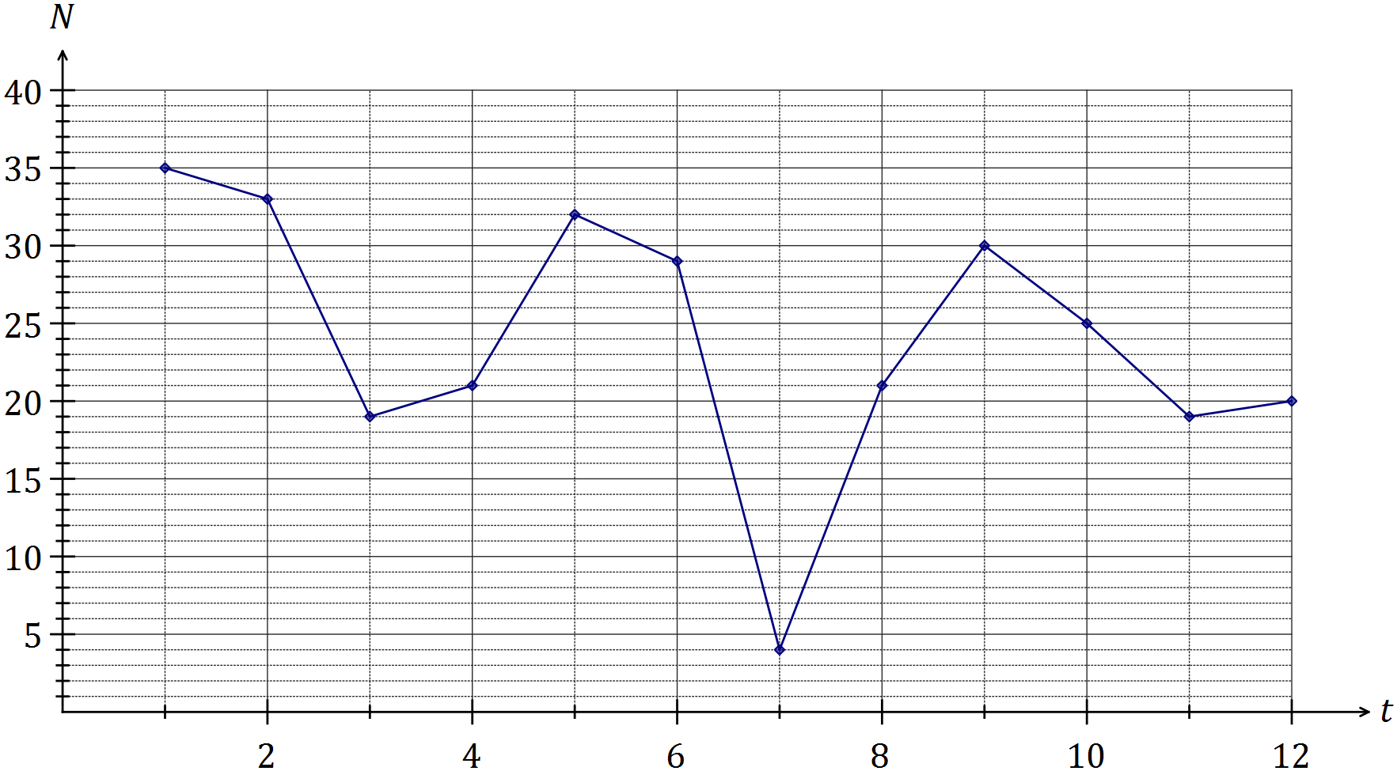

(b) Comment on features of the time series plot, including trend and seasonality. (3 marks)

|  |
| --- |
| **Solution** |
| Trend is decreasing - fewer members are turning up each day  Weekly (4 day) seasons, with most on Mons and least on Weds  Likely outlier on Wed of Wk 2, much lower than other two Weds |
| **Specific behaviours** |
| ✓ comments on decreasing trend  ✓ comments on seasons  ✓ comments on outlier, or other relevant feature |

(c) The trend line for the data is $N=30-0.9t$. Comment on the usefulness of this line as a short and long term trend model. (2 marks)

|  |
| --- |
| **Solution** |
| Model is useful in the short term but not in the long term as it predicts a negative number of swimmers after just over 30 days, which makes no sense. |
| **Specific behaviours** |
| ✓ indicates useful in short term but not in long term  ✓ includes at least one reason in response |

(d) State the days which have the highest and the lowest seasonal index

Highest – Monday, Lowest - Wednesday

Question 5 (6 marks)

(a) When collecting data as part of a statistical investigation, state a reason why a student

(i) may choose to take a sample from the population under study. (1 mark)

|  |
| --- |
| **Solution** |
| Easier; Quicker; Not possible to locate all members of population; etc |
| **Specific behaviours** |
| ✓ states a valid reason |

(ii) would prefer a large sample rather than a small sample. (1 mark)

|  |
| --- |
| **Solution** |
| Larger samples tend to be less biased/give more valid results/etc |
| **Specific behaviours** |
| ✓ states a valid reason |

(b) A student investigated the relationship between the number of emails, $x$, and the number of text messages, $y$, received by nine people during a weekday and found that there was a weak negative linear relationship between the variables.

(i) Use the axes below to sketch a possible scatter plot that reflects this information.

(2 marks)

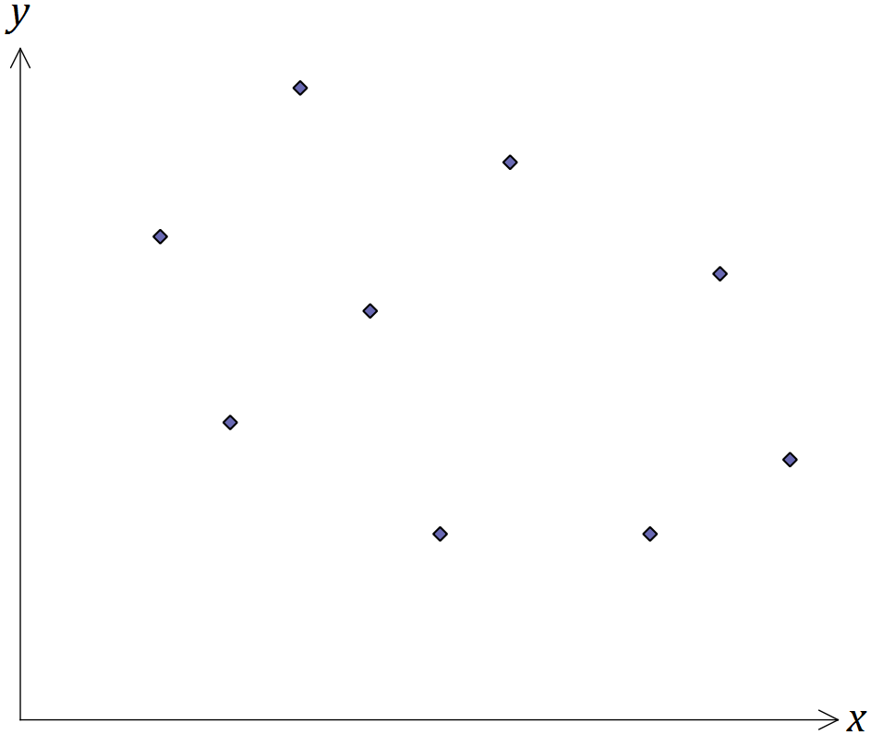

|  |
| --- |
| **Solution** |
| See graph |
| **Specific behaviours** |
| ✓ clear negative trend  ✓ 'oval' with nine points |

(ii) Place a cross on the scale below for the best estimate you can make for the value of the correlation coefficient between the two variables. (1 mark)

|  |
| --- |
| **Solution** |
| See number line |
| **Specific behaviours** |
| ✓ places cross between -0.2 and -0.5 |



(iii) Suggest a reason for the relationship the student found. (1 mark)

|  |
| --- |
| **Solution** |
| Personal preference to use one rather than both forms of communication |
| **Specific behaviours** |
| ✓ any plausible reason |

Question 6 (6 marks)

(a) A simple connected graph has 4 edges and $V$ vertices. State all possible values of $V.$

(2 marks)

|  |
| --- |
| **Solution** |
| $$\left(V=\right) 4 \text{or} 5$$ |
| **Specific behaviours** |
| ✓ either value  ✓ both values, no others |

(b) A simple connected graph has $E$ edges and 4 vertices. State all possible values of $E.$

(2 marks)

|  |
| --- |
| **Solution** |
| $$\left(E=\right) 3, 4, 5 \text{or} 6$$ |
| **Specific behaviours** |
| ✓ at least three correct  ✓ all values, no others |

(c) Draw a simple connected graph that has 5 vertices and is Eulerian but not Hamiltonian.

(2 marks)

|  |
| --- |
| **Solution** |
|  |
| **Specific behaviours** |
| ✓ draws simple connected graph with 5 vertices, all vertices even degree  ✓ draws one of above (or isomorph) |

Question 7 (7 marks)

The table below shows all but one of the seasonal indices for the daily sales figures for a recently opened pop-up store that is closed on Mondays and Tuesdays.

|  |  |  |  |  |  |
| --- | --- | --- | --- | --- | --- |
| Day | Wednesday | Thursday | Friday | Saturday | Sunday |
| Seasonal index | 0.65 | 0.70 |  | 1.35 | 1.50 |

(a) Determine the seasonal index for Friday. (2 marks)

|  |
| --- |
| **Solution** |
| $0.65+0.7+1.35+1.5=4.2$ $5-4.2=0.8$ |
| **Specific behaviours** |
| ✓ indicates given values must add to 5  ✓ evaluates missing index |

(b) One weekend, the pop-up store had sales worth $3 000 on Saturday and $3 000 on Sunday. If these sales figures were deseasonalised, which day would have the highest sales? Justify your answer. (2 marks)

|  |
| --- |
| **Solution** |
| Saturday. $3000÷1.35$ will be bigger than $3000÷1.5$. |
| **Specific behaviours** |
| ✓ chooses Saturday  ✓ gives a reasonable explanation |

(c) The equation of the trend line for deseasonalised sales, $S$ in dollars, after the store had been open for $t$ days was $S=195t+1640$.

(i) Interpret the value of the slope of this line in this context. (1 mark)

|  |
| --- |
| **Solution** |
| Sales are increasing by $195 per day that store is open. |
| **Specific behaviours** |
| ✓ states sales are increasing by 195 per day |

(ii) Write down an expression that would forecast the actual sales of the pop-up shop on the Wednesday when $t=31$. **Do not** evaluate your expression. (2 marks)

|  |
| --- |
| **Solution** |
| $$(195×31+1640)×0.65$$ |
| **Specific behaviours** |
| ✓ substitutes time into trend line  ✓ multiplies trend value by seasonal component, using brackets |

Question 8 (8 marks)

A school has received quotes from venues A, B, C and D to host teams of students to play knockout competitions in basketball, hockey and volleyball. The four venues can only host one sport at a time and their quotes, in hundreds of dollars, for each sport are shown below.

|  |  |  |  |  |
| --- | --- | --- | --- | --- |
|  |  | Sport | | |
|  |  | Basketball | Hockey | Volleyball |
| Venue | A | 28 | 23 | 23 |
| B | 27 | 23 | 30 |
| C | 25 | 26 | 22 |
| D | 30 | 24 | 27 |

(a) If venues B, C and D are chosen for basketball, hockey and volleyball respectively, calculate the total cost. (1 mark)

|  |
| --- |
| **Solution** |
| $27+26+27=80⇒\$8 000$ total cost |
| **Specific behaviours** |
| ✓ calculates total cost |

(b) Represent the choice of venues for each sport as a bipartite graph. (2 marks)

|  |
| --- |
| **Solution** |
|  |
| **Specific behaviours** |
| ✓ two distinct sets of points  ✓ joins to create complete bipartite graph |

(c) Show use of the Hungarian algorithm to determine a suitable allocation of sports to venues in order to minimise the total cost, and state the minimum cost. (5 marks)

|  |
| --- |
| **Solution** |
| $\left[\begin{matrix}28 & 23 & 23 & 0 \\ 27 & 23 & 30 & 0 \\ 25 & 26 & 22 & 0 \\ 30 & 24 & 27 & 0\end{matrix}\right]⇒\left[\begin{matrix}3 & 0 & 1 & 0 \\ 2 & 0 & 8 & 0 \\ 0 & 3 & 0 & 0 \\ 5 & 1 & 5 & 0\end{matrix}\right]⇒\left[\begin{matrix}2 & 0 & 0 & 0 \\ 1 & 0 & 7 & 0 \\ 0 & 4 & 0 & 1 \\ 4 & 1 & 4 & 0\end{matrix}\right]$ Allocate basketball to C, hockey to B and volleyball to A.  Hence minimum cost is $25+23+23=71⇒\$7 100$ |
| **Specific behaviours** |
| ✓ adds dummy column  ✓ subtracts column minimums from each column  ✓ subtracts smallest uncovered (1) from uncovered and adds to twice covered  ✓ identifies allocation  ✓ calculates minimum cost |

Additional working space

Question number: _________

© 2016 WA Exam Papers. Kennedy Baptist College has a non-exclusive licence to copy and communicate this paper for non-commercial, educational use within the school. No other copying, communication or use is permitted without the express written permission of WA Exam Papers.